Isabelle Anno
9/28/2022

Chapter 5 exercises
3.) List the trip name of each trip that has Miles Abrams as a guide.

SELECT TRIP_NAME from TRIP, TRIP_GUIDES WHERE TRIP.TRIP_ID = TRIP_GUIDES.TRIP_ID
AND GUIDE_NUM = 'AM01'
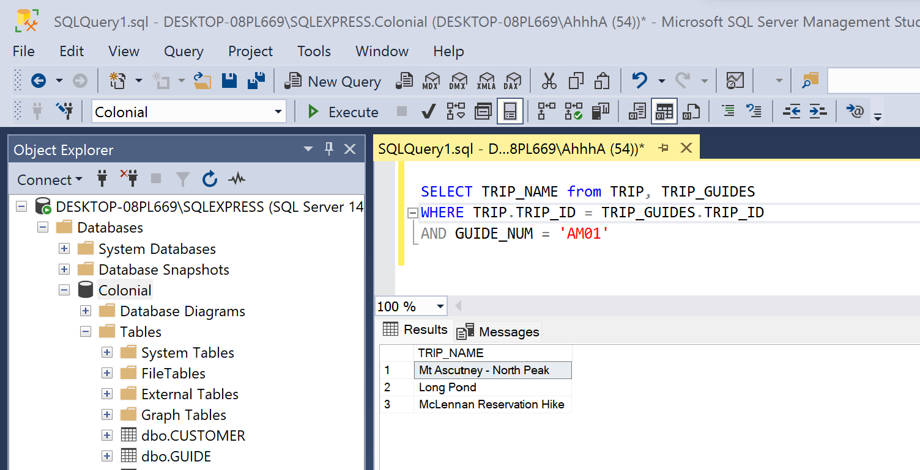
7.) List the reservation ID, trip ID, and trip date for reservations for a trip in Maine. Use the EXISTS operator in your query.

SELECT RESERVATION_ID, RESERVATION.TRIP_ID AS RESERVATION_TRIP_ID, TRIP_DATE
FROM RESERVATION WHERE EXISTS (SELECT * FROM TRIP WHERE RESERVATION.TRIP_ID = TRIP.TRIP_ID AND STATE = 'MA')
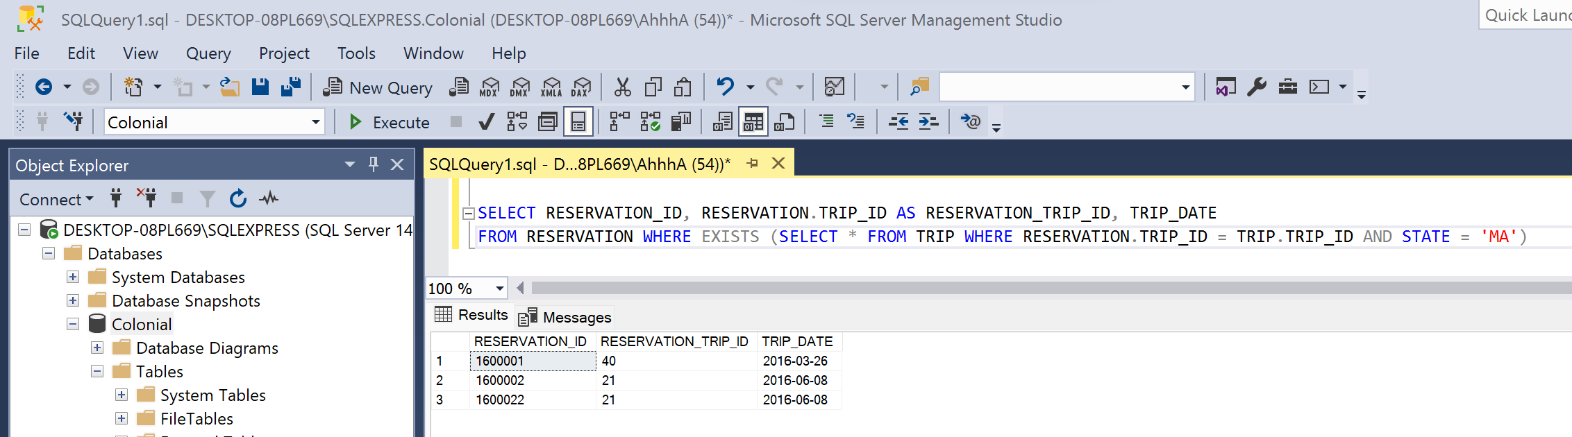

11.) Find the trip name of all reservations for hiking trips and sort the results by trip name in ascending order.
SELECT TRIP_NAME FROM TRIP, RESERVATION WHERE TRIP.TRIP_ID = RESERVATION.TRIP_ID AND TYPE = 'HIKING' ORDER BY TRIP_NAME ASC
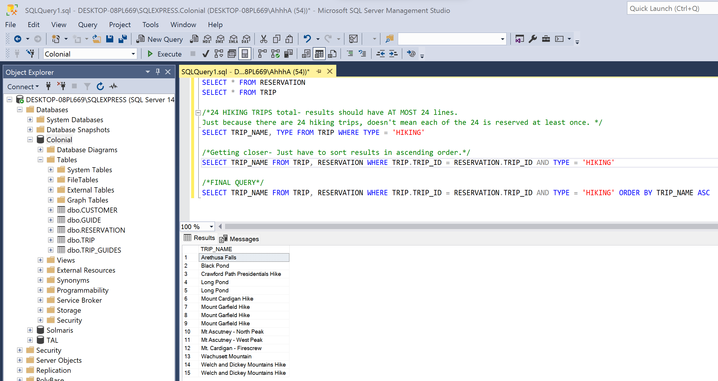

13.) List the number and name of each customer that lives in the state of NJ and that currently has a reservation.
SELECT FIRST_NAME, LAST_NAME, PHONE FROM CUSTOMER, RESERVATION WHERE CUSTOMER.CUSTOMER_NUM = RESERVATION.CUSTOMER_NUM AND STATE = 'NJ';

